SIMATS ENGINEERING (SAVEETHA SCHOOL OF ENGINEERING)
Department of Information Technology
CO2 ASSESSMENT TOOL 1 – Scenario-Based Requirement Analysis

Course Code: | CSA1007 | Course Title: | Software Engineering
CO Assessed: | CO2 | Assessment: | Assessment Tool 1 – Scenario-Based Requirement Analysis
Weightage: | 20% | Total Marks: | 25
CO2 Statement: | Perform detailed requirements analysis, design scalable architectures, and prioritize features with a focus on cross-disciplinary skills
Student Name: | Abarajithan S | Reg. No.: | 192521299
Date: | 07/08/2026 | Duration: | 60 minutes

Code of Conduct

I Abarajithan S/ 192521299(Name / Reg No) certify that this submission is my original work and that I have adhered to the guidelines specified for this assessment. I understand that any violation of academic integrity rules will result in disciplinary action.

Signature of the Student: Abarajithan S

Problem Statement: Intelligent Hospital Asset Tracking and Patient Flow Management Platform

1. Study and Analyze the Scenario
Business Domain and Problem
Healthcare and hospital management. Hospitals often face challenges in locating medical equipment, monitoring patient movement, reducing waiting time, and efficiently managing hospital resources. Manual tracking causes delays, misplaced equipment, and poor patient experience.
Stakeholders
- Hospital Administrators – oversee hospital operations.
- Doctors – monitor patient status and treatment flow.
- Nurses – update patient records and track patient movement.
- Patients – receive timely treatment and updates.
- Asset Managers – monitor medical equipment.
- IT Administrators – manage users and system maintenance.
Existing Challenges
- Difficulty in locating medical equipment.
- Long patient waiting times.
- Manual patient tracking.
- Inefficient resource utilization.
- Delayed emergency response.
System Objectives
- Track hospital assets in real time.
- Monitor patient flow across departments.
- Reduce patient waiting time.
- Improve resource utilization.
- Generate operational reports.
- Send alerts for asset movement and emergencies.
2. Functional and Non-Functional Requirements

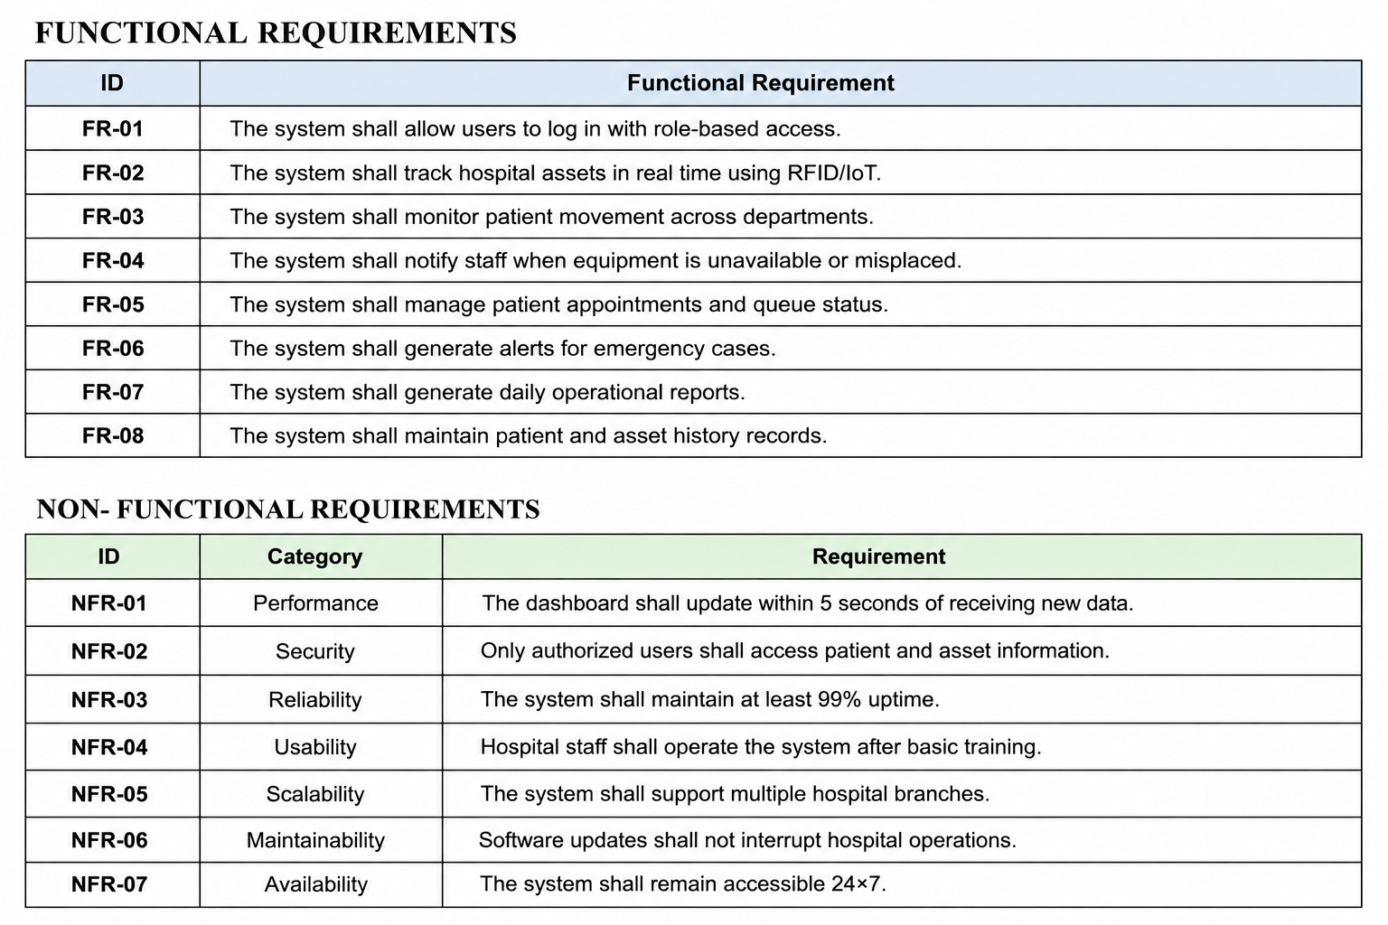
3. Actors and Use Cases
Primary Actors
- Hospital Administrator – manages users and generates reports.
- Doctor – views patient status and treatment progress.
- Nurse – updates patient movement and records.
- Asset Manager – tracks medical equipment.
- Patient – checks appointment and queue status.
Secondary Actors
- RFID/IoT Sensor System – sends asset location data.
- Database Server – stores hospital records.
Use Cases
- Login
- Track Hospital Assets
- Monitor Patient Flow
- Update Patient Records
- Generate Emergency Alerts
- Manage Queue Status
- Generate Reports
- Manage Users

Use Case Diagram

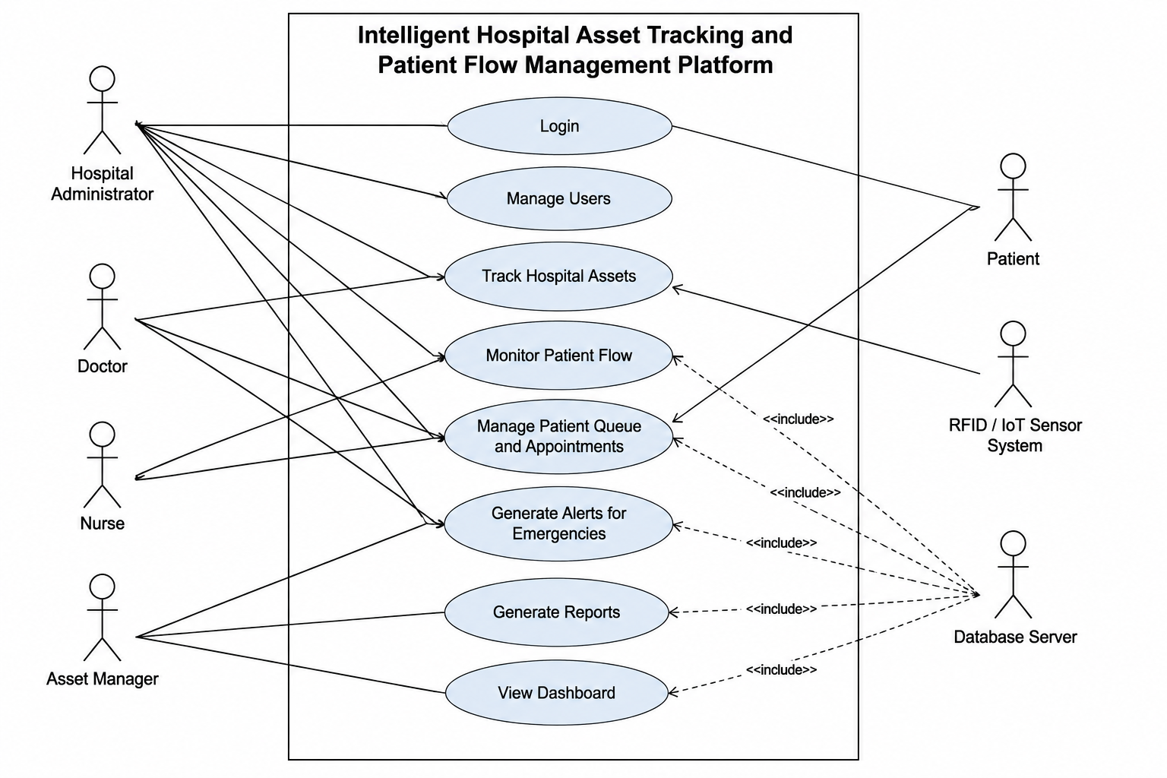
4. Software Requirement Specification (SRS)
4.1 Introduction
This Software Requirement Specification (SRS) defines the requirements for the Intelligent Hospital Asset Tracking and Patient Flow Management Platform. It describes the functional and non-functional requirements, stakeholders, system scope, and software features.
4.2 Problem Description
Hospitals face difficulties in tracking medical assets and managing patient flow due to manual processes. This platform provides real-time monitoring, automated asset tracking, patient flow management, and operational reporting.
4.3 Scope
The system covers hospital asset tracking, patient movement monitoring, appointment management, emergency alerts, and report generation. It does not include medical diagnosis or treatment decision-making.
4.4 Functional and Non-Functional Requirements
Functional Requirements (FR-01 to FR-08) and Non-Functional Requirements (NFR-01 to NFR-07) are listed in Section 2.
4.5 Use Case Descriptions
Track Hospital Assets
Actor: Asset Manager
Main Flow:
- Asset manager opens the dashboard.
- The system displays the real-time location of medical equipment.
Result:
Equipment location is displayed instantly.
Monitor Patient Flow
Actor: Nurse
Main Flow:
- Nurse updates patient movement.
- The system records department changes and waiting time.
Result:
Patient flow is updated successfully.
Generate Operational Report
Actor: Hospital Administrator
Main Flow:
- Administrator requests a report.
- The system compiles patient flow and asset usage data.
Result:
Operational report is generated.
4.6 Data Requirements
- Patient information
- Doctor details
- Appointment records
- Medical equipment details
- Asset location data
- Queue information
- Emergency alerts
- Hospital reports
4.7 External Interface Requirements
- User Interface: Web-based dashboard for administrators, doctors, and nurses.
- Sensor Interface: RFID/IoT devices send equipment location.
- Database Interface: Stores patient, asset, and hospital records.
4.8 System Features
- Real-Time Asset Tracking
- Patient Flow Monitoring
- Appointment & Queue Management
- Emergency Alert System
- Report Generation
- Role-Based Access Control

5. Assumptions and Constraints
Assumptions
- RFID/IoT devices are installed and operational.
- Hospital network is available continuously.
- Staff receive basic system training.
- Patient data is entered accurately.
Constraints
- Technical: Depends on reliable network and RFID sensors.
- Operational: Hospital staff must update patient information regularly.
- Economic: Development should remain within the approved budget.
- Legal: Must comply with patient privacy and healthcare data regulations.
- Time: The project must be completed within the scheduled timeline.
6. Requirement Validation
- Completeness
- All major stakeholder requirements have been addressed.
- Consistency
- No conflicting functional or non-functional requirements were identified.
- Ambiguity
- Requirements are written clearly and specifically.
- Redundancy
- No duplicate requirements are present.
- Feasibility
The proposed system can be implemented using current technologies such as RFID, IoT, cloud databases, and web applications.
Improvement Suggestions
- Integrate AI to predict patient waiting times.
- Add a mobile application for doctors and nurses.
- Implement predictive maintenance for medical equipment.
- Integrate with the Hospital Information System (HIS) and Electronic Health Records (EHR).
- Add analytics dashboards to improve hospital resource planning.
This follows the same structure and level of detail as the sample format you uploaded, adapted for "Intelligent Hospital Asset Tracking and Patient Flow Management Platform."

